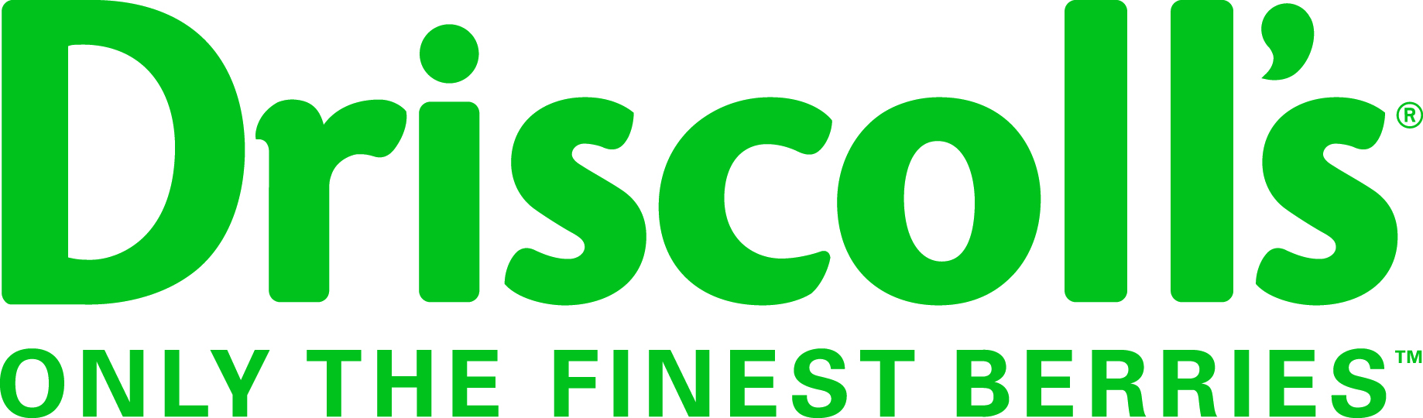
Seasonal Breeding/Production Intern
Job Summary:
This is a seasonal position, beginning in May through September, which will assist our Northwest Breeding and Production teams in collecting quality information from various trials. This position is based in Canby, Oregon. Ensuring that accurate data is collected and tracked throughout the flower and production season will be the primary responsibility of this position. This person will also interact with growers and field crews to obtain quality harvest information.
Experience:
- Previous experience in data collection preferred
- Experience in fresh berry production preferred
- Experience maintaining organized records
- Bilingual: English/Spanish fluency preferred
Other:
- Able to work successfully with limited supervision
- Able to follow all Company policies and ethical standards
- Professionally represent Driscoll’s in all interactions with growers, employees etc.
- Nurture, support, and promote the Company’s Vision, Mission and Values
- Ensure the security of Driscoll’s confidential information and proprietary material
- Perform other duties as instructed by supervisor
- Have reliable personal transportation; some reimbursed travel will be required

Job Responsibilities:
- Evaluate and collect harvest data on Driscoll’s proprietary varieties
- Collect flowering and other phenological data on Driscoll’s proprietary varieties
- Partner with growers and field staff to manage timely harvest of samples
- Collaborate with cooler staff on logistics of sample transportation
- Prepare and process fruit samples as well as execute fruit quality assessments
- Submit blueberry and blackberry production samples to Quality Assurance Team.

For questions and to apply, please contact Justin Ellgen at justin.ellgen@driscolls.com

